Thursday 12:10 p.m. Radisson Hotel
Vol. 85 No 6 124 Members

NEXT WEEK

15-Aug-2013 Dana Schmidt
Foreign Exchange Student

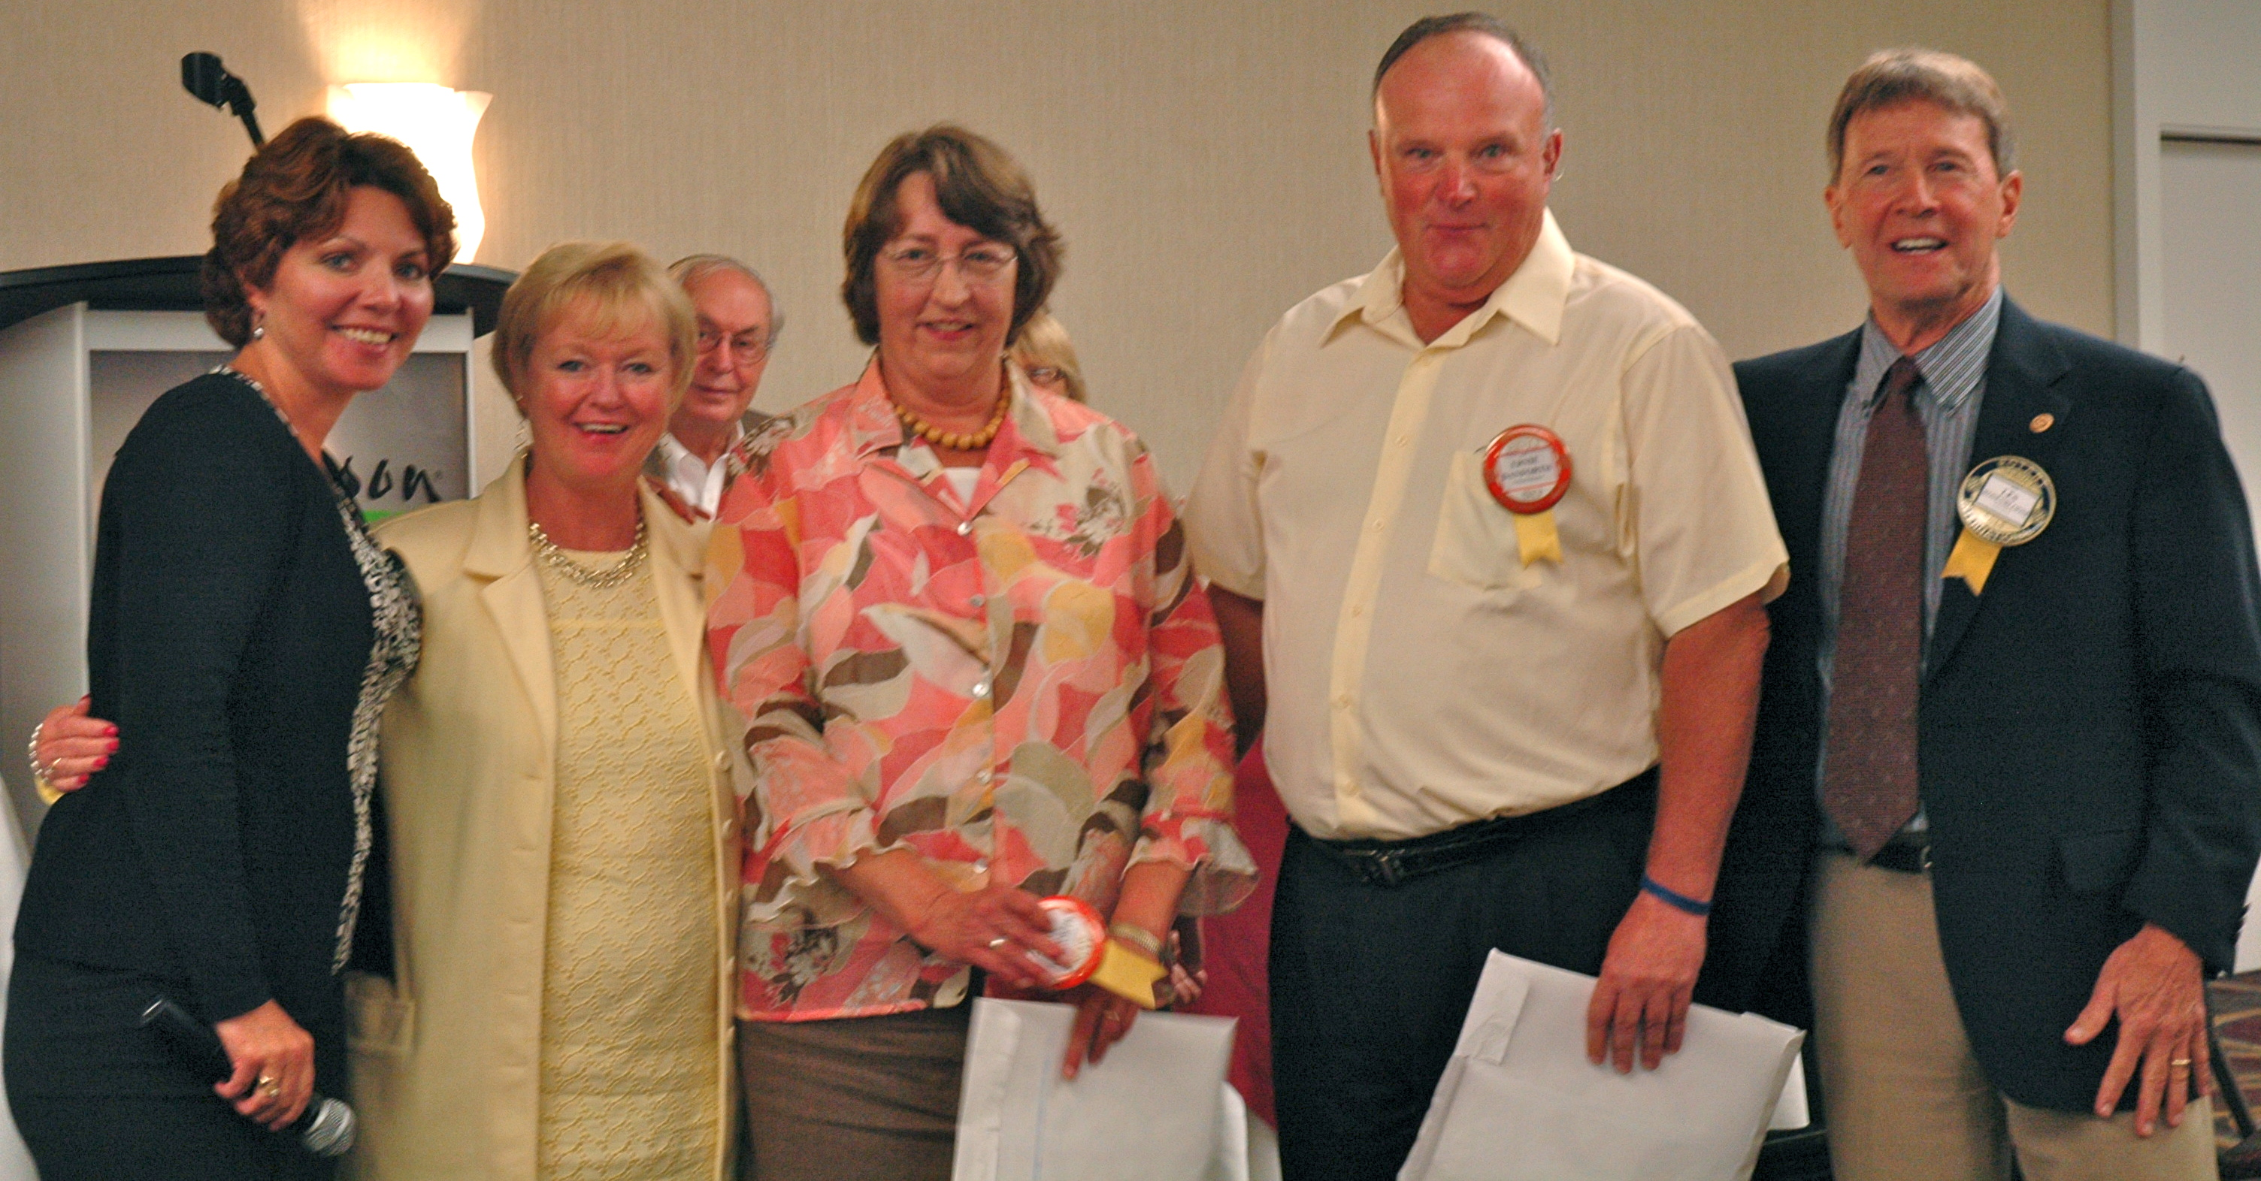
COMING UP

22-Aug-2013 Dr. William Powell
American Chestnut Trees

29-Aug-2013 Ellen Hughes
District Governor

In the Keuka and Seneca Rooms, about 60 members and guests were present. Jim Hudson was at the keyboard tickling the ivories for our entertainment prior to the opening bell. Father Lew Brown was asked to make the invocation and make it he did. In honor of his navy pilot guest he recited the Air Services hymn: “Eternal Father”. Jon Carpenter’s phone went off and Michele’s budget was $5 richer and richer still when Kate Foss and Charlie O’Hess paid $5 each to retrieve their badges.

GUESTS: Kristy Kager was called upon to introduce visiting Rotarians and guests and performed her duty with aplomb. Dick Pope had our speaker’s mother, Lori Friend and Father Brown introduced Carolyn and Pete Schranz. Sam, of course, had Audrey and Les Rosenbloom had our soon to be members, Kate and Ernie Danforth. We welcomed back our visiting Rotarian, George Miller from Arab, Alabama. Rosetta Kellberg introduced Phyllis Jensen and Kristy had Ellen Thomson back for a visit.

Corning Night at Camp Star is Monday. August 12th, from 6:30 to 8:30 p.m.
New Members: Nancy Latour and Les Rosenbloom double-teamed us in introducing Kate and Ernie Danforth to the gathered assemblage, With Nancy doing the honors for Kate and Les following and sometimes preceding with Ernie’s accomplishments.

They both have received Chancellors Awards for Excellence in teaching while Ernie received a second Chancellors Award for Scholarship and Creative Activities, Kate, not to be outdone received one for Professional Development. Both have received CCC Trustees Awards for Excellence in Teaching. Both taught math at CCC, Ernie serving as Department Chair and Kate as a coordinator. Both were chair of the Faculty Association -- Kate TWICE.

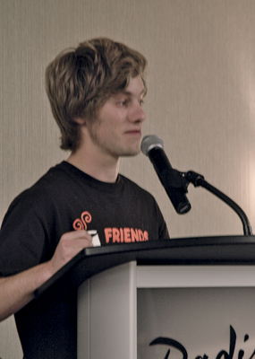
Both were president of NYSMATYC, NYS Mathematics Association of Two Year Colleges and they each received the NYSMATYC for Outstanding Contributions to Math Education.

In addition Kate received the Teaching Excellence Award from American Mathematics Association of Two Year Colleges. Both have been active in the First Presbyterian Church as elders, deacons, trustees, in the hand bell choir or singing in the choir, as Sunday School teachers. Both have also been active in the Two Bit Players -- either backstage, chorus or acting roles. Ernie has been assistant basketball coach for both women’s and men’s teams, tallying 28 years. Kate and Ernie have three children and at one time all were teaching at the college.

MEMBER ANNOUNCEMENTS: Paul Rossi touted the mini golf tournament on the 13th of September with a $50 sponsor fee/hole. The new CEO of our YMCA is due on August 26th. Bill Boland brought a ducky umbrella to announce that tonight was the Duck Race. Charlie Hess claimed that one of his two tickets would win. Bill has recently received a Lifetime Achievement Award from the Space Foundation, whose long-term goal is to establish permanent settlements on moons or planets. For receiving the award he contributed $50 to Polio Plus.

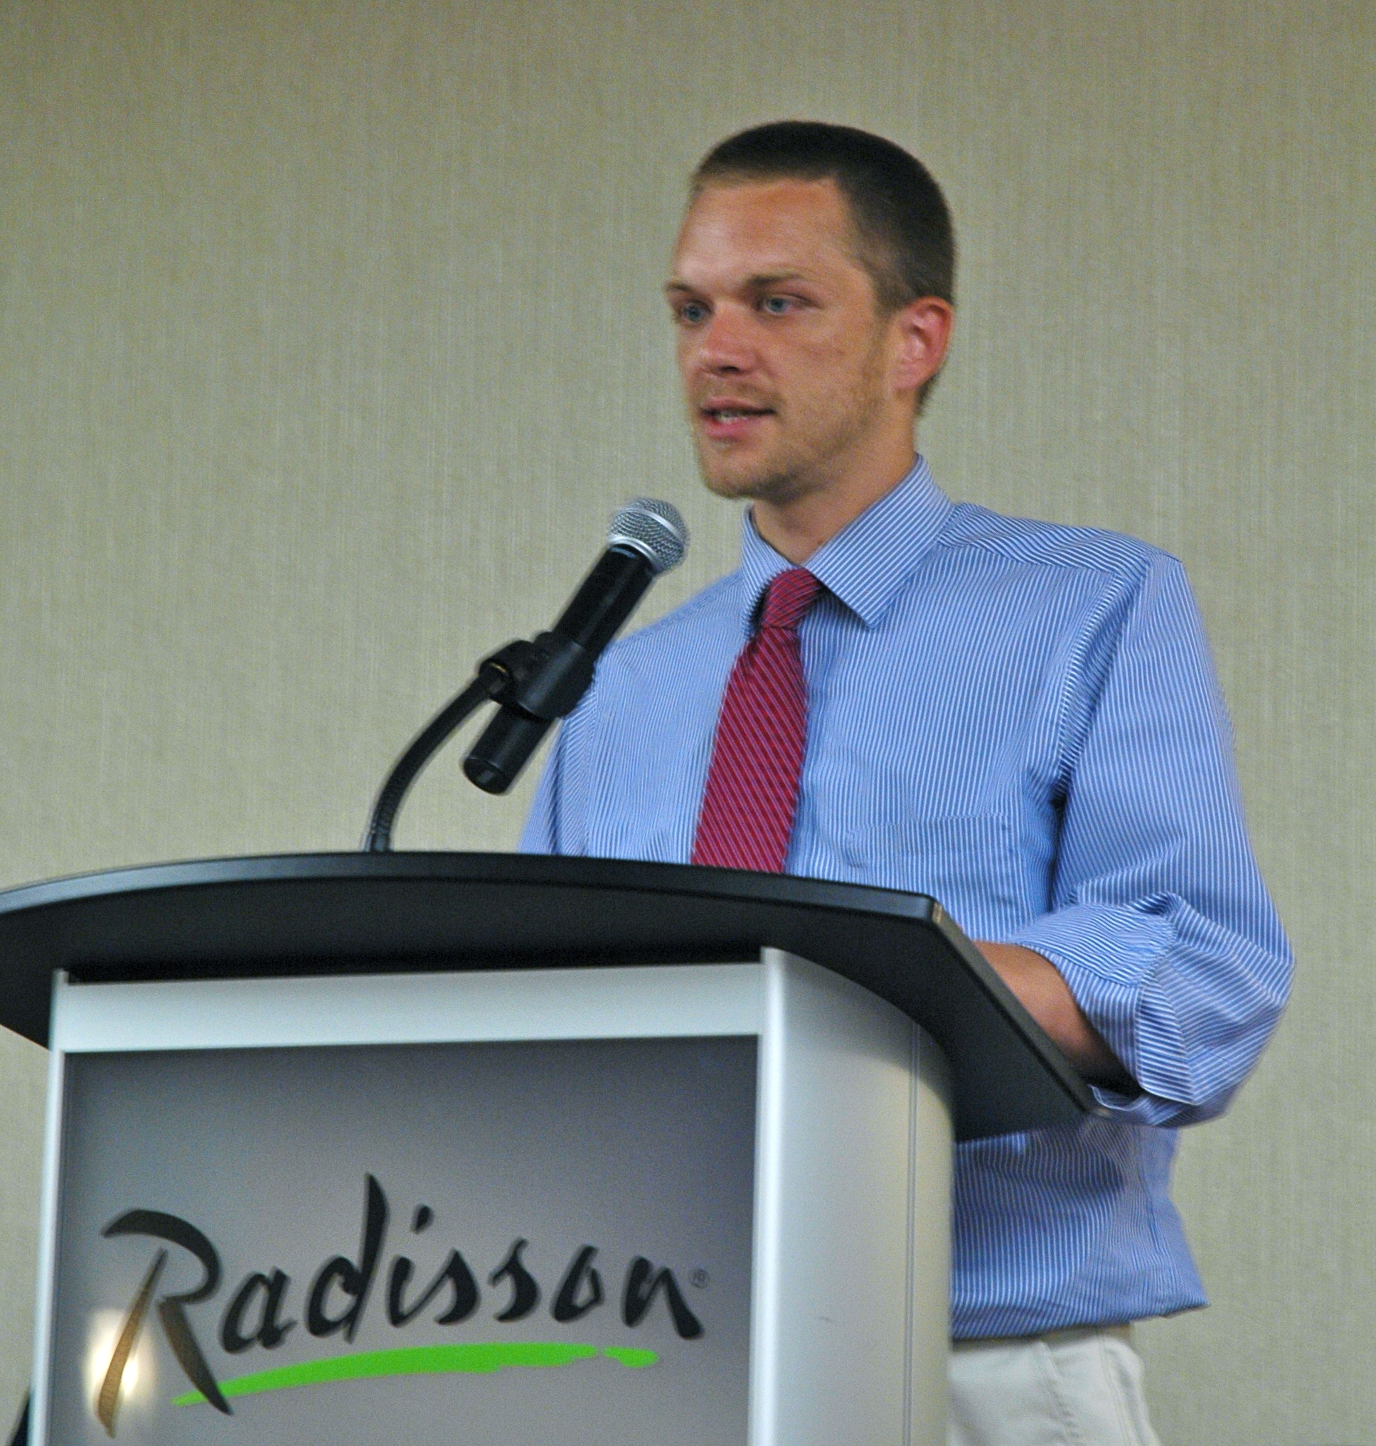
FINE TIME: On Julien’s last day with us, he was given the power of the purse: clipping Sam for $1 for Audrey not being a member, Brian Klotz for $2, Teddy boy for $2, Andy Taylor for $3 and Bill Boland for $1. But yours truly was asked his age, Julien doubted Bill was that young and made him dig into his wallet for 25 smackeroos. He returns home next week and will be attending college in the Netherlands. He promises to keep in touch through SKYPE (Whatever that is).

PROGRAM

Dick Pope introduced Sean Friend, a second year student at CCC in Environmental Engineering. NOVA and TED talks are his favorite programs. His original major was EE until a year ago when he took a one-credit course and learned about Aquaponics. He was intimately familiar with Hydroponics having set up a system as a hobby having grown tomatoes in a water medium with no soil and 1/10th the water needed for growing them in soil.

They can be grown year-round using a 40 watts of light. On the downside, it is expensive to do it on a small scale, his first system costing $1200 and in excess of $300/month. A study by Stanford University predicts that within 50 years, ocean fishing would crash. In order to feed the world, he believes one solution is fish farming, i.e. Aquaponics. For carnivorous fish, like trout, a one-pound trout will eat three pounds of prey fish and will need to be treated with antibiotics.

He built his own system for $75 and with 300 fish grew some fifty two plants, lettuce and mint being especially prolific. As he explained, it is a closed system; the fish poop feeds the plants, which convert the nitrites to nitrates which the fish then utilize.

Aquaponics is booming in Australia. They have produced a 50 page document and a two hour video. He has acquired 300 fish from BOCES and his goal is to raise vegetables using tilapia and carp. It took him 30 minutes to build his system. It is a 50-gallon tank with 250 fish requiring a pump at 65 W and a 400 W light.

In fielding questions, he mentioned that salmon and trout other than brook get stressed when in small enclosures, leading Walter to suggest psychiatric care.

In response to another question, he said prawns are extensively grown using Aquaponics.

POP QUIZ: Name this bald pate:

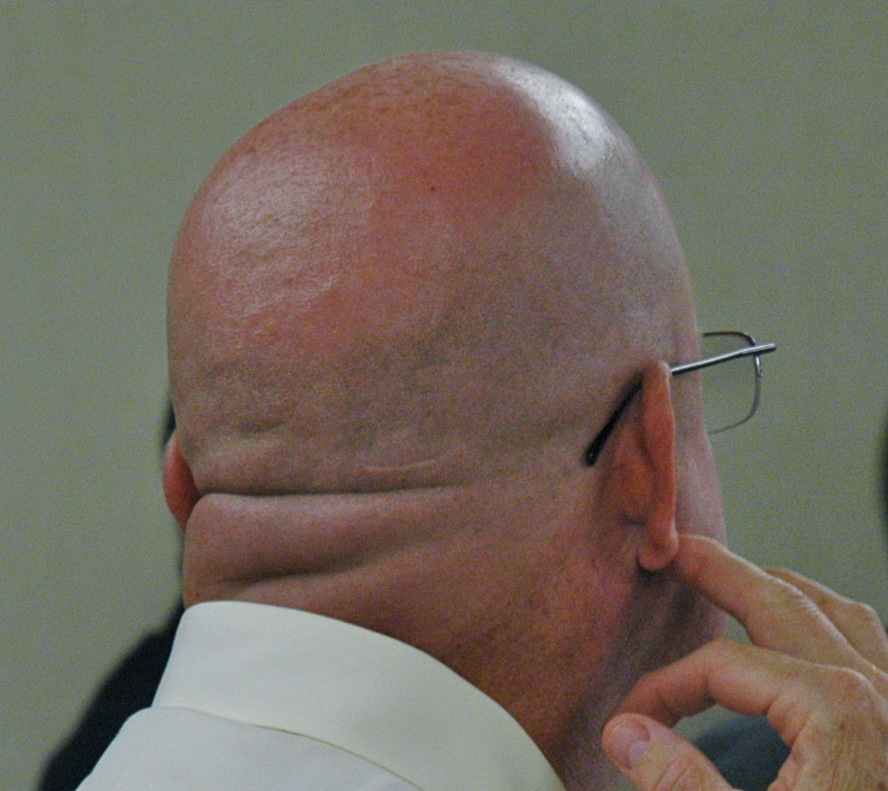

NEXT WEEK: Dana Schmitt: Her year in Germany

50/50: Sure win $15, Pot: $255

Photos: Boland

remmulp

